St Mary’s Church of England Junior Academy

Parent, Carer & Visitor
Conduct Policy

Policy Type:  Date Issued by MAT:  Approved By:  Approval Date:  Review Date:  Person Responsible: | Trust Policy  25/03/2024  Executive Team  25/03/2024  March 2027  Chief Executive Officer

Our Christian Ethos and Values

Our academies are open to all and accepting of all regardless of faith. Our passion and ambition are to see children and young people in all our academies achieve excellent educational outcomes alongside developing and growing into their potential as individuals made in the image of God.

Our culture is one of high aspiration for all. This is rooted in our Christian values as demonstrated in the life and teachings of Jesus Christ. We have a desire to see our academies acknowledged as places of aspiration, high quality learning, achievement and hope making a significant contribution to the communities they serve.

All policies within St Benet’s Multi Academy Trust (hereafter referred to as “the Trust”), whether relating to an individual academy or the whole Trust, will be written and implemented in line with our Christian ethos and values.

Overall accountabilities and roles
The Trust has overall accountability for all its academies and staff. Through a Scheme of Delegation for each academy it sets out the responsibilities of the Trust, its Executive Officers, the Local Governance Committee and the Principal / Head Teacher. The Principal / Head Teacher of each academy is responsible for the implementation of all policies of the Trust.
All employees of the Trust are subject to the Trust’s policies.

Contents
1. Trust Policy Statement 4
2. Introduction, Scope and Policy Aims 4
3. Expected Behaviour 5
4. Inappropriate Behaviour 5
5. Responding To and Managing Inappropriate Behaviour 6
6. Policy Monitoring and Review 7
Appendix 1: Template Inappropriate Behaviour by a Visitor Report Form 8
Appendix 2: Procedures for Barring an Individual from School Site 9
Appendix 3: Template Banning Letter 10
Appendix 4: Example Letter Template to Send to Parents 11
Appendix 5: Poster to be Displayed on School Premises 13

1. Trust Policy Statement

St Benet’s MAT considers the safety of everyone in all of our schools as the highest priority in our organization. As such, the Trust has a zero-tolerance approach to abusive or threatening behaviour throughout both the Trust Head Office and all of our academy premises for all adults, including visitors.

As part of our focus on diversity and inclusion, the Trust pledges that our policies will seek to promote equality, fairness and respect for all. Our policies reflect the St Benet’s MAT values of responsibility, aspiration, dignity, love and respect. By working closely with a range of stakeholders, such as our school, union, and HR colleagues, we have ensured that Trust policies do not unlawfully discriminate against anybody.

For the purpose of this policy, the term Trust refers to St Benet’s MAT. The term ‘school’ and the term ‘academy’ are interchangeable. The term ‘pupil’ and the term ‘student’ are interchangeable. Visitors include, but are not limited to, parents/carers, wider family, members of the community, external agencies and other guests.

2. Introduction, Scope and Policy Aims

The Trust is committed to ensuring that all of our Trust and school environments are safe for everyone and that all adults act as role models to our pupils in the way that they conduct themselves. Although fulfilling a public function, the Academy is a private place. The public has no automatic right of entry. The Academy may, therefore, need to act to ensure they remain a safe place for pupils, staff and other members of their community.
Throughout the Trust we seek to maintain positive relationships with members of our school communities and value strong relationships with all stakeholders as we recognise that these relationships are fundamental to the success of our pupils.

According to DFE Guidance on Controlling Access to School Premises, people do not have an automatic right to enter school premises. Visitors (including parents), however, do have what is known as an ‘implied licence’ to come onto school premises at certain times for certain reasons. Examples include appointments or meetings, school events and to drop off or collect younger children.

The vast majority of visitors to the Trust’s academies, whether they are parents, wider family, members of the community or other guests, demonstrate the values which we want to promote to our students in our academies. We value the positive interaction between staff, volunteers and the families of our students and we will always listen to any concerns and seek to address them.

Unfortunately, there are occasions where visitors do not conduct themselves in a manner we would deem acceptable. All academies have been encouraged to consider what to do in circumstances where unsatisfactory conduct arises. The Trust owes a duty of care to all persons at our academies – staff, volunteers, students, Trustees and Governors.

The purpose of this policy is to outline the behaviour expected of adults visiting our schools, as well as detailing the procedures in place for dealing with any instances where behaviour falls below these expectations.

3. Expected Behaviour

The Trust expects all adults visiting the Trust central offices or one of our academies to:

- Act in a way and use language that is consistent with our Trust values of responsibility, aspiration, dignity, love and respect as well as the ethos of the school they are visiting.
- Respect the school environment by keeping it clean and tidy.
- Work in partnership with staff to resolve any concerns in a positive manner. This includes clarifying their child’s version of events with the school who can gather information that gives a holistic perspective of any situation.
- Correct their child’s behaviour appropriately, particularly where it could otherwise lead to conflict, aggression or a lack of safety.
- Respect that staff may not always be immediately available and an appointment may be required.
- Follow site-specific rules in relation to parking, one-way systems, visitor signing-in procedures etc.
- Show consideration and respect for all staff, pupils and other visitors including parents of other pupils.

In light of the above, when on school premises, the Trust expects that adults visiting our schools will not:

- Discriminate against any individual, whether a staff member, pupil or other visitor, on the basis of a protected characteristic under the Equality Act 2010.
- Engage in inappropriate conversations with any pupils that they may encounter upon their visit. If they have any concerns about a pupil, they should report it to school staff immediately in line with the safeguarding procedures at that school.
- Engage in conversations with others about pupils, staff or other adults within the school community that are unrelated to the concerns about their child.
- Discuss any issues of a confidential matter outside of school, or to anyone whom it does not concern within the school.

4. Inappropriate Behaviour

Throughout the Trust we take instances of inappropriate behaviour very seriously and will not tolerate any circumstances which may make staff, pupils or any other member of the school community feel threatened or uncomfortable.

The following are examples of what the Trust considers to be inappropriate behaviour at our central office or any of our schools. This list is not exhaustive and other types of behaviour that cause harm or distress to any member of the school community will also fall under the remit of this policy:

- Any form of actual or threatened violence including behaviour which causes alarm or distress.
- Verbal abuse including swearing or using other offensive or discriminatory language.
- Shouting at individuals either in person or over the phone.
- Using aggressive gestures or body language such as raising a fist or finger.
- Sending any form of abusive or offensive communication about a member of the school community, including on social media.
- Making defamatory, offensive, or derogatory comments about a school or any member of the the Trust community, including on social media.
- Any form of harassment whether in person or online.
- Disruptive behaviour that interferes with the operation of the school.
- Causing intentional damage to property.
- Trespassing on school property.
- Breaching security procedures (e.g. not following visitor sign-in protocols).
- Approaching someone else’s child to discuss/chastise them in relation to perceived/actual actions towards their own child.
- Targeting/ bullying behaviour towards another child, for example if they have specific needs.
- Aiming to discuss or requesting information about another person’s child.
- Smoking, drinking alcohol or taking illegal drugs on school premises.
- Dangerous driving on school premises.
- Sending repeated and vexatious emails to the school.

Should any of the above actions take place at the Trust Head Office or one of our school premises, we may feel it is necessary to take action in line with this policy including contacting the Police if we feel a criminal offence has occurred.

5. Responding To and Managing Inappropriate Behaviour

The Trust recognises that situations in school can often be complex, challenging and emotive. This does not stand in the way of our commitment to ensuring that our Trust and school environments are as safe as possible for everyone, however, we understand that a prescribed approach to managing inappropriate behaviour by visitors isn’t necessarily apt depending on the context and severity of the situation.

The following are examples of responses to inappropriate behaviour that may be utilised by Headteachers, Trust and school leaders in order to ensure the safety and wellbeing of all members of the school community. The list is not exhaustive and leaders may take other appropriate measures in the interests of safeguarding staff and pupils:

- In any instances of physical violence, calling the Police immediately.
- Barring an individual from the school premises when an incident is severe or the inappropriate behaviour is repeated (see Appendix 2 for further details).
- Inviting anyone who is behaving inappropriately into a separate and private room so they have the opportunity to collect themselves and calm down.
- Terminating any meetings where inappropriate behaviour is persistent or severe.
- Asking anyone who is behaving inappropriately to leave the school site.
- In instances where an individual is refusing to leave the school site or attends whilst they are barred, calling the Police to remove them in line with the Education Act 1996 s547.
- Following up any instances of inappropriate behaviour with a verbal warning, either via phone call or in a separate meeting, advising that repetition of such conduct may result in a ban from the school site.
- Following up any instances of inappropriate behaviour with a written warning advising that repetition of such conduct may result in a ban from the school site.
- Appointing a single point of contact for individuals who have behaved inappropriately.
- Where there is conflict between two people with parental responsibility for a child, arranging separate meetings (e.g. parent consultation evening appointments).
- Instructing a single method of communication with individuals who have behaved inappropriately (e.g. email only if verbal abuse has taken place over the phone).

If an incident involving inappropriate behaviour does occur, then an incident report form (see Appendix 1) will be completed by the Headteacher, a member of their Senior Leadership Team or a Trust leader. This will be stored in a secure drive with access only by designated professionals in the school i.e. the Headteacher and Deputy Headteacher and HR Officer.

Leaders will ensure that appropriate aftercare and support is put in place for any member of the the Trust community who is affected by an incident.

6. Policy Monitoring and Review

Monitoring of the impact of this policy will be undertaken through our governance processes in each school and at Trust level. The policy will be reviewed every 3 years.

Appendix 1: Template Inappropriate Behaviour by a Visitor Report Form
This report form to be kept confidential.
A summary of the concern if it relates to the wellbeing of a child to be added to CPOMS.

Name of School
Name of Person Completing Form
Date of Incident |  | Time of Incident
Location of Incident

Name of Perpetrator(s) | Role (Staff/Parent/Visitor etc)

Name of Victim(s) | Role (Staff/Parent/Visitor etc.)

Incident Code(s)
Details of Incident:
Was the Incident Deemed to be Discriminatory in Nature?
Is this a Repeated Incident by this Person?
Action Taken:

Appendix 2: Procedures for Barring an Individual from School Site
DFE Guidance on Controlling Access to School Premises clearly states that a school may bar someone from their premises if they feel that their aggressive, abusive or insulting behaviour or language is a risk to staff or pupils. It is enough for a member of staff or a pupil to feel threatened.

In the event that the Trust or one of our schools have to take this course of action, the following process will be implemented:

- The school will inform the CEO and the Head of Safeguarding that they intend to bar a person from their school site so that appropriate support and guidance can be provided. This may include consultation with the Trust’s legal advisors.

- Next, the Headteacher will inform the person in writing that they have received an interim bar or that they intend to bar them from the school premises, setting out the reasons behind this intention.

- The individual has a right to present their side of the situation so the Headteacher should invite them to make written representations or attend a meeting to give them this opportunity.

- The Headteacher will inform the individual of the outcome in writing. If the decision is to bar them from school premises, this correspondence should detail the timescale for which the barring applies and when the decision will be reviewed.

- The welfare of any children affected by the decision remains paramount. All measures should be taken to safeguard them and promote their wellbeing. For example, if the individual barred is a parent and the child needs dropping off or collecting, the Headteacher should ensure that this can be done safely with minimal disruption to the child’s education.

- The Headteacher and CEO should review any bars on a termly basis to see whether they need to remain in place. This should take into account any subsequent behaviour of the individual who is barred and balance the risk to safety of staff/pupils against the rights of the individual to attend the school premises. The decision that the Headteacher makes is final.

- Where a person who is barred is unhappy about the process regarding a decision, they should refer to the Trust Complaints Policy and follow those procedures.

Appendix 3: Template Banning Letter

[Insert date]

[Insert name and address]

Dear [insert name],

St Mary’s Church of England Junior Academy

As Chief Executive Officer of St Benet's MAT I am writing to you on behalf of Miss Richardson Headteacher of the above academy. I summarise the issue of concern below:

- [insert day, date and time of incident followed by details of incident]

Miss Richardson and the St Benet’s Trust Board have an obligation to protect the health and safety of staff and children attending the academy. Your behaviour and actions towards [insert names as appropriate] will not be tolerated and accordingly St Benet's MAT proposes to withdraw consent for you to be present on the school premises until [insert date] at which time the ban will be reviewed and may, at the discretion of the Headteacher, be continued or lifted.

Before I take the proposed action I wish to give you the opportunity to make representations in relation to both the issues set out above and the proposal to ban you from the academy premises.
You have until [insert date] to make representations to me. If you wish to make representations in person, rather than in writing, please telephone before [insert date] to arrange a suitable time.

During the period from now until [insert date] St Benet's MAT and St Mary’s Junior Academy has imposed an interim ban and you must not enter school premises for any reason, including school open days and parent evenings, without the express written consent of Miss Richardson

If, after consideration of your representations, Miss Richardson decides to ban you from the school premises until [insert date] and you enter onto the school premises without the express consent of Miss Richardson you will be both trespassing and committing a criminal offence under Section 547 of the Education Act 1996. I confirm that, in these circumstances, St Benet's MAT, on the instructions of the Headteacher, has the power to commence appropriate proceedings against you.

Yours sincerely,
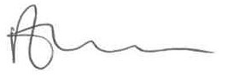
Richard Cranmer
Chief Executive Officer

Appendix 4: Example Letter Template to Send to Parents

Dear Parents & Carers,

Communication with School

We understand that communication is very important, and we are always keen to work with you to address any concerns that you may have. We recognise that it can be difficult, especially when you are dealing with issues that are worrying or emotive, and we understand that you will want to reach solutions as quickly as possible.

We will aim to respond to communication within a 48-hour period and, where we can, more quickly if it is a safeguarding or time-sensitive issue. Teachers on full teaching timetables may take longer to reply because of the commitment on their time. Equally, many support staff are involved in classroom activities and meetings and so cannot respond straight away.

It is important to us that we protect the wellbeing of our staff. For this reason, we ask that where possible you do not contact our staff after 6.00pm. There are obvious exceptions to this including any safeguarding concerns where you need to make us aware of information. Please note that our office hours are 8am to 3:30pm and in the case of an emergency we would always stress the need to call a service that is a 24-hour emergency responder such as the Police, Health Service or crisis lines.

The vast majority of our home-school communications and interactions are very calm, positive and constructive and we would like to thank you for this. Occasionally, interactions are less positive. It is very important to us that all staff working in our school are treated with respect and courtesy and that they are not subject to any behaviours that could cause emotional or physical harm.

In order to support a peaceful and safe school environment the school cannot accept the following behaviours:

- Conduct which undermines the safe and calm environment in the school, either in the classroom, in the school office, around the school site or immediately outside school premises.
- Using loud or offensive language or displaying an unacceptable amount of anger and aggression.
- The use of aggressive or intimidatory body language.
- Threatening physical violence to a member of the school community.
- Damaging school property.
- Abusive telephone calls, emails, letters or other form of written communication.
- Defamatory comments about school staff on social media.
- The use of physical aggression towards a child or adult.
- Approaching someone else’s child to chastise them.

Where parents, carers or visitors do not conduct themselves in an appropriate manner during meetings or discussions, the meeting/conversation will be terminated. If this meeting is taking place in school the parent/carer/visitor will be asked to leave the school site. In the first instance, the Headteacher or appropriate senior member of staff will seek to resolve the situation through discuss and agreed actions. Where conduct has been such as to warrant it, the Police will be informed.

In the case of a serious incident, or repeated incidents, the school may need to instigate proceedings (where applicable through Legal Services) to ban persons acting in such a manner from the school site. This action will not be taken lightly but will be deemed necessary if members of staff are at risk of harm.

A record will be maintained in school of all incidents involving intimidating or threatening behaviour towards staff.

Thank you for taking the time to read this letter and I look forward to positive interactions and engagements with you all for the benefit of the children and adults throughout our community.

Yours faithfully,

Miss Laura Richardson

Headteacher

Appendix 5: Poster to be Displayed on School Premises
A pdf version of the poster is available from suzannah.kay@stbenets.org.
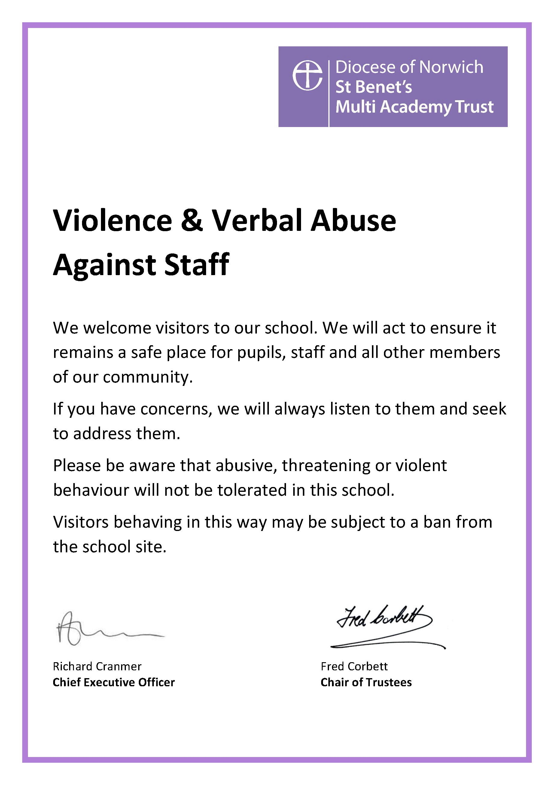

Please use the incident codes provided below: Discriminatory Language DL Provocative Behaviour PB Physical Assault PA Driving Related DR Written Abuse/Threats WA Ridicule/Ostracism RO Social Media SM Harassment H Verbal Abuse/Threats VA Damage to Property DP Alcohol/Drugs AD Other O
The Crime and Disorder Act 1998 recognises that hostility based on a person’s race, religion, disability, sexual orientation or transgender identity can be prosecuted as a hate crime.

